Developing a Window Insert

Prepared by [Liam Brown]

Date: [2020-11-15]

Abstract

This report presents the design and feasibility analysis of a homemade window frame panel intended to reduce thermal bridging. The design adds an extra layer of insulation around the window frame. Using ridged insulation, plywood and gorilla tape the panels were assembled to a south and west facing window. The two window frames with panels were tested against windows without panels. The comparison data demonstrated that the windows with the homemade window frame panel was five percent more effective than the window without, meaning that the panel was an effective addition to the homes envelope.

Contents

1. Introduction 4

2. Background/Context 4

3. Methodology 5

4. Window Frame Panel 5

4.1. Materials 5

4.2. Assembly Considerations 5

4.3. Assembly Technique 5

4.4. Figures 6

5. Performance of Window Frame Panel 7

5.1. Observations 7

5.2. Conclusion 7

# Introduction

The weakest part in a building envelope is the window frame. Most Canadians struggle with heat loss during the winter which leads to more energy loss or freezing cold homes. In 2007 the average Canadian “spent $1187 [1]” on keeping their HVAC and lights running. The only way to prevent that would be to come up with a solution to help with heat transfer.

The purpose of this project is to test a new approach to window assembly and compare it to the classic assembly. This will be accomplished by considering the cost of installation compared to the inefficiency of the heat loss. Of course adding the insulation to the outside will increase R-Value but in this project will assess overall efficiency.

These different assemblies will be compared to show contrast between the two assemblies and how they react in direct sunlight at different parts of the day.

# Background/Context

Windows generally present a tension between insulation and price. Strong insulating quality such as the “ANDERSEN E-SERIES these windows are 70% more energy-efficient in the summer and 45% more energy-efficient in the winter [2]” is difficult to find at a reasonable prince. Upgrades focus on two different components: the window, the window frame and the window pane.

There are five common window frame types for residential: wood, wood clad, vinyl, hybrid, and composite. Wood is usually favorable in residential houses because of its availability and appearance. Wood clad is very similar to wood except it has cladding on the exterior which makes it more durable. Vinyl, also known as “polyvinyl chloride[3]” is also very common for window frames. Vinyl frames are very resistant to weather and don’t need to be maintained. “Manufactures are increasingly turning to hybrid frames[3]”. Hybrid frames are made up of both vinyl and wood. The vinyl exterior helps with a maintenance free exterior while the wood interior gives you a nice sill to finish to. Composite is made up of wood chips and glue. It is less common right now due to composite being such a new product but could have many benefits considering it can be any shape. These are all basic frames and if the owner would like to add insulation to the inside of the frames or more thermal breaks in the vynal the client could be looking at paying the difference between “$300 per window [or] $550 at the low end and $850 at the high end[4]”.

Most the windows available today are double pane but maximum efficiency and sound proofing come with an upgrade to triple pane. In places like southern BC there is no point in upgrading to three panes because you may not see a return on the money you spent for a long time due to “warmer climate [5]”.

# Methodology

Two windows, one east and one south facing were selected. Half of each window assembly was upgraded with a new assembly as seen in Figure (5). Every week the window frames temperature would be checked when they were in direct sunlight. “These times ranged from 8:30-9:30 for the east window and 11:00-1:00 for the south window[6]”. The window was monitored in eight different spots. Two spots on the outside of the window in direct sunlight and four on the inside. Then using the data taken from the two different window assemblies compile the data and compare heat ratings.

# Window Frame Panel

## Materials

The materials used to develop the two window frame panels were: two sheets of DOW one and a half inch by four feet by nine feet Styrofoam Cladmate CM20 Ship Lap Foam Insulation, one roll of Gorilla Adhesive Tape - Tough and Large, and a quarter inch sheet of plywood which was chosen to imitate a false window frame for aesthetics.

## Assembly Considerations

Assembling the window panel there was a few things that needed to be taken into consideration: the insulation panel needed to overlap past the middle to help with thermal bridging which was solved by extending the insulation one foot past the center, the insulation needed to be fastened together, to the wall, and without damaging the existing wall without creating any thermal bridging this was done by using minimal gorilla tape which proved to be a reliable durable tape leaving minimal marks when removed.

## Assembly Technique

Constructing the two window frames begins with cutting the two panels in half with an exacto knife. Next the observer will measure the height of the existing jam of the window frame and cut one of the ridged insulation pieces to match the size of the jam then measure the length of the sill of the window frame and cut another piece to half that size plus three feet to match the bottom of the jam piece and extend one foot past the center to prevent thermal bridging. Then you will cover the back face of the ridged insulation with ripped down quarter inch plywood. The plywood is assembled to the back of the insulation because the color and glazing of the insulation is closer to the color and glazing of the vynal window frame which helps get closer and more accurate data due to light reflectance. After collecting all the pieces and dry fitting them to the window the operator will use the gorilla tape to fasten the panels to the window frame. It is important that there is enough tape to hold the panel in place for at least two hours at a time to get an accurate representation of what the window panel is doing for the window frames assembly.

## Figures

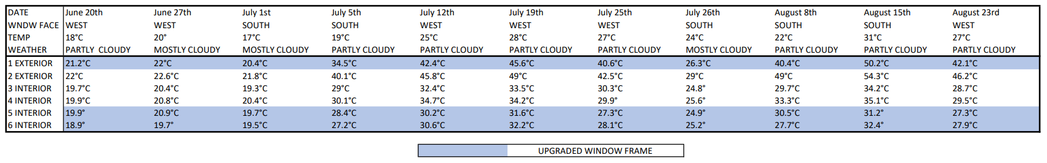

Figure 1: Collected Data

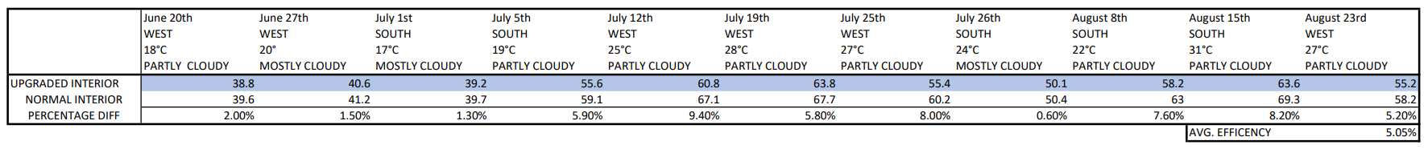

Figure 2: Analysed Data

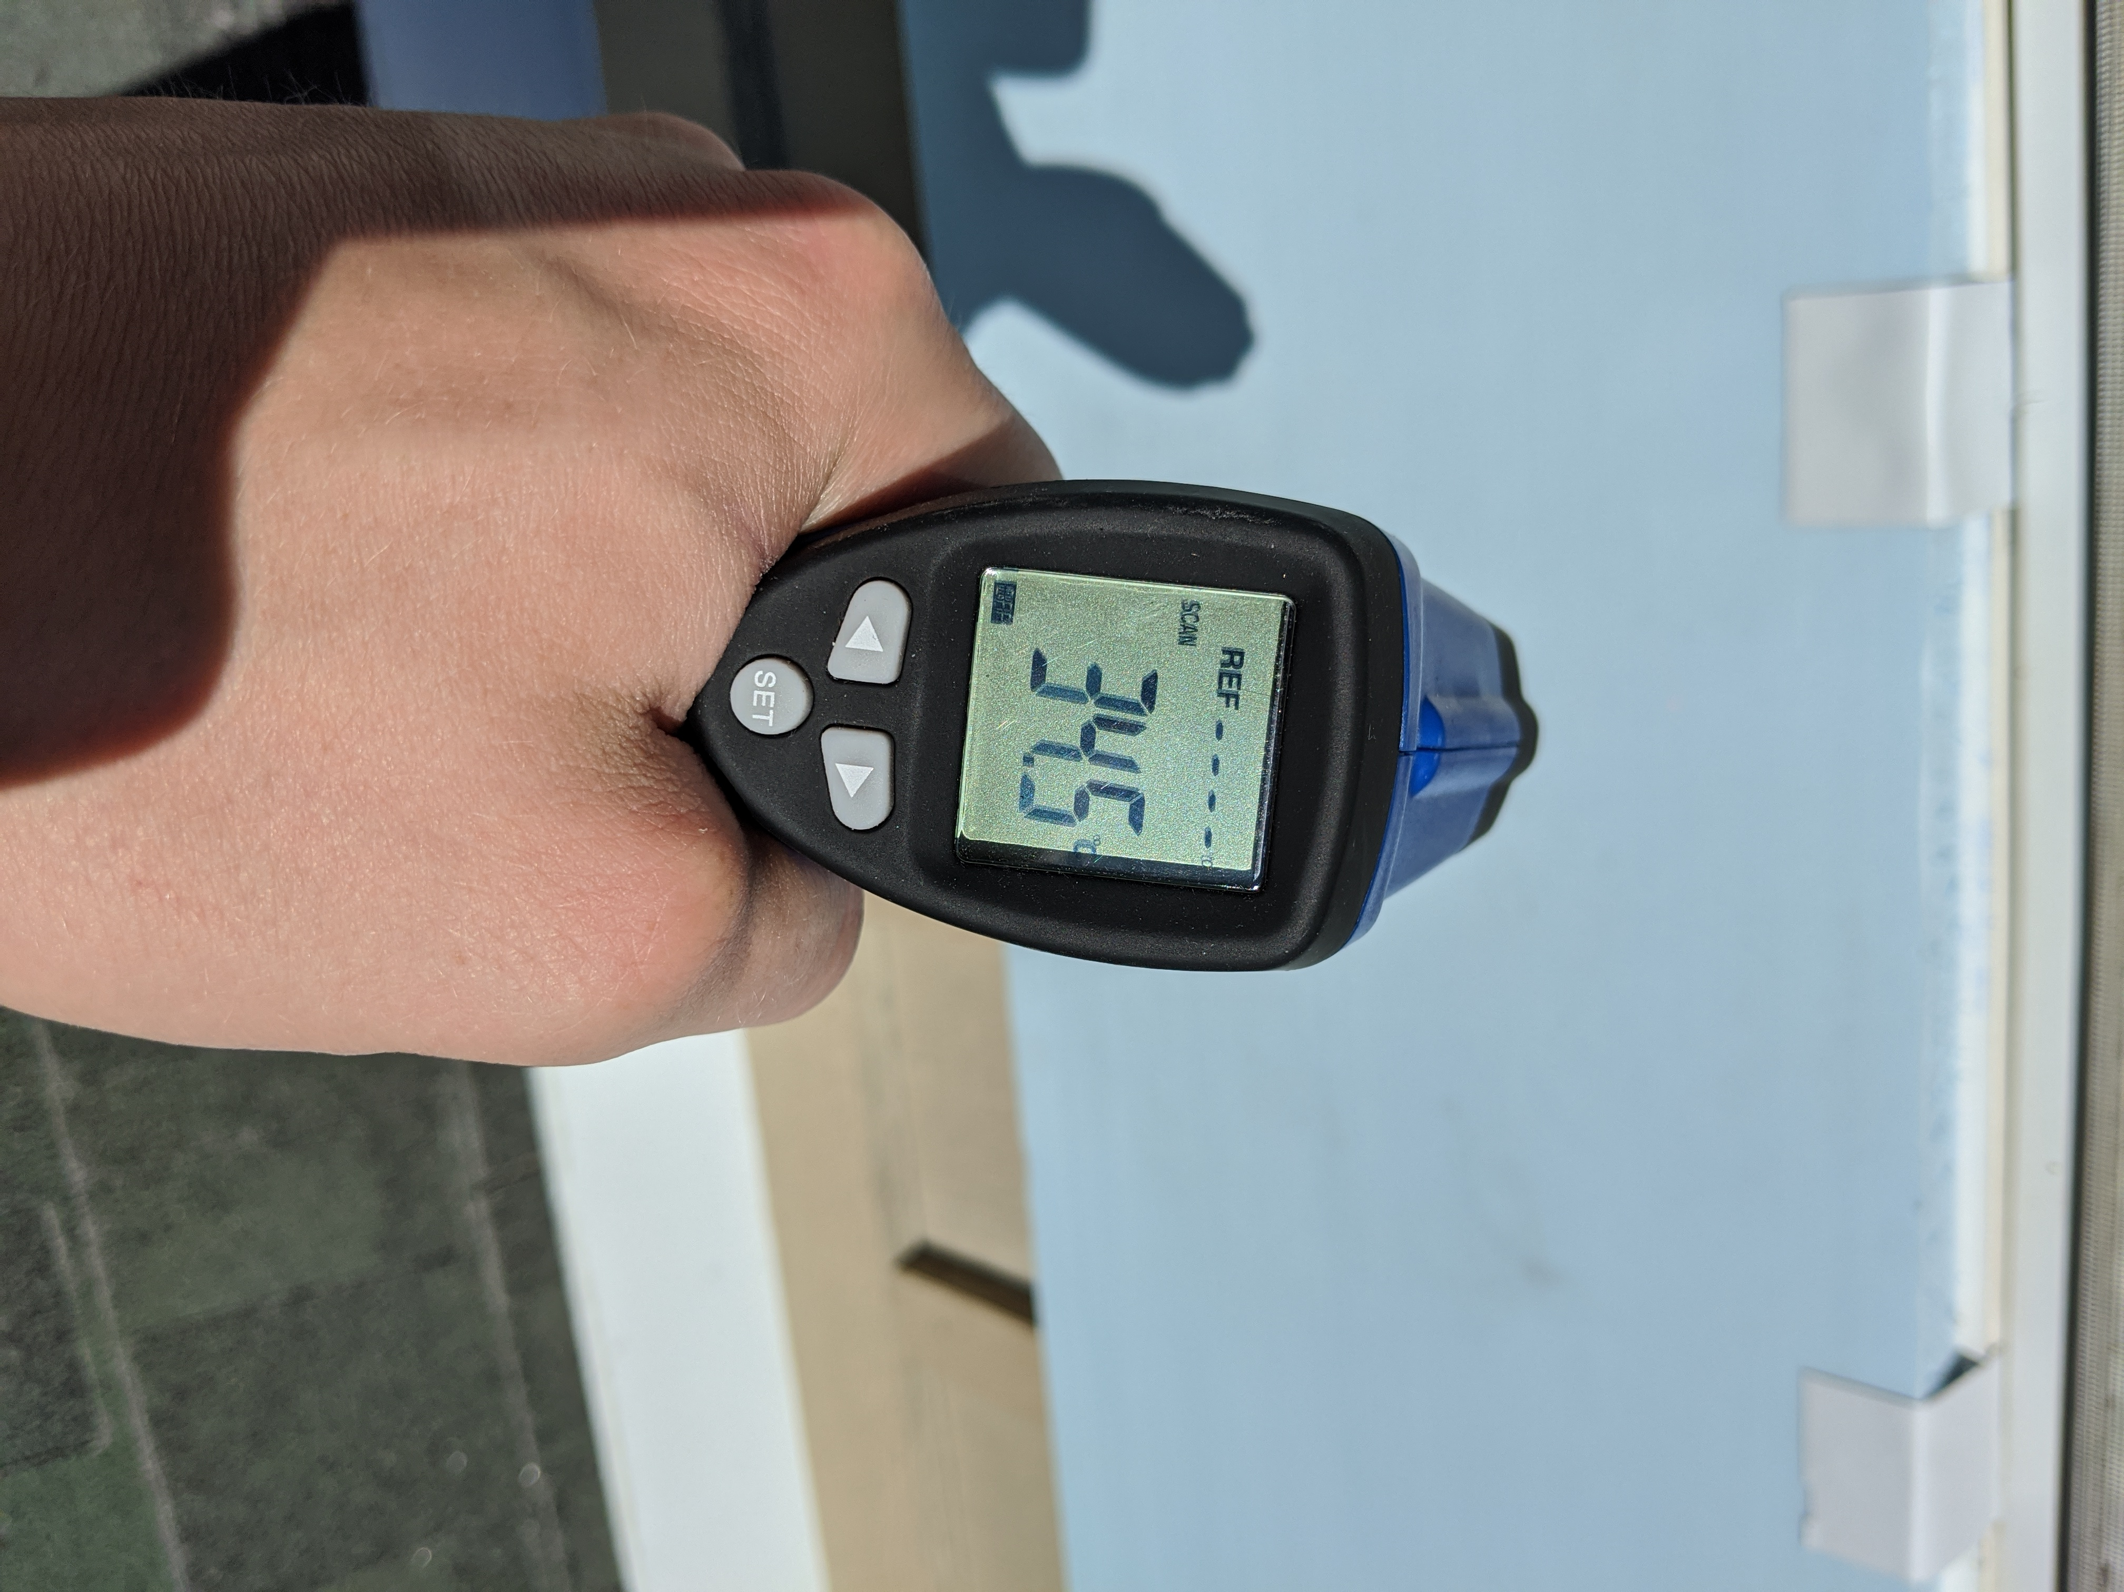

Figure 3: Taking Data 1

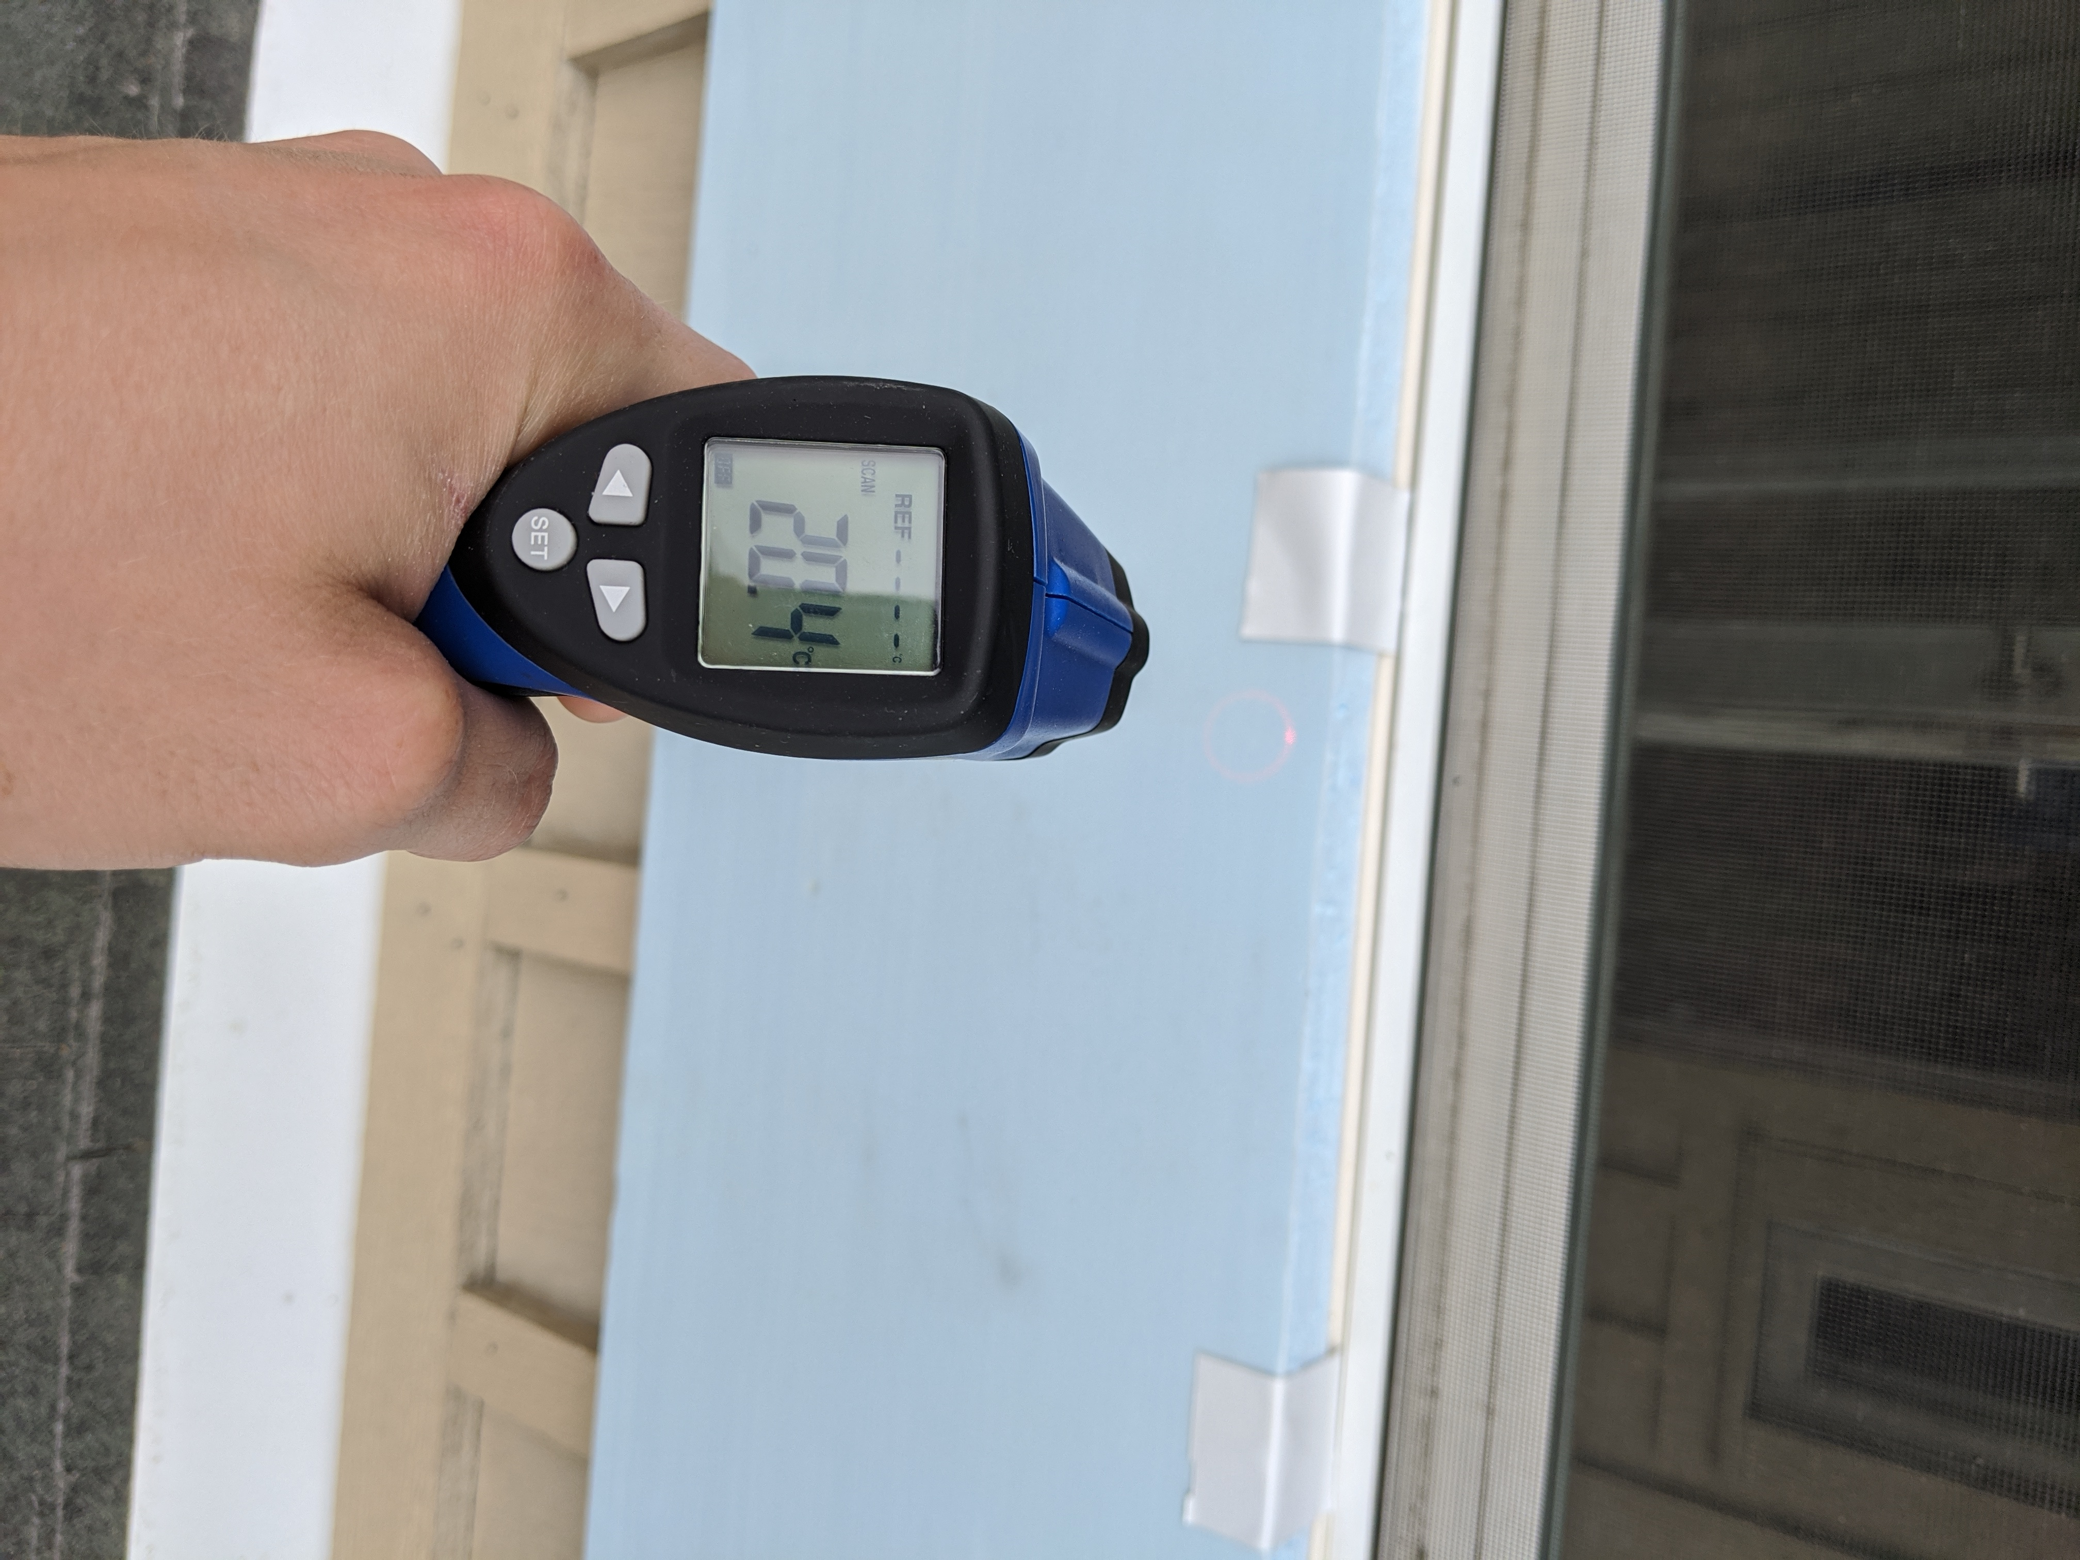

Figure 4: Taking Data 2

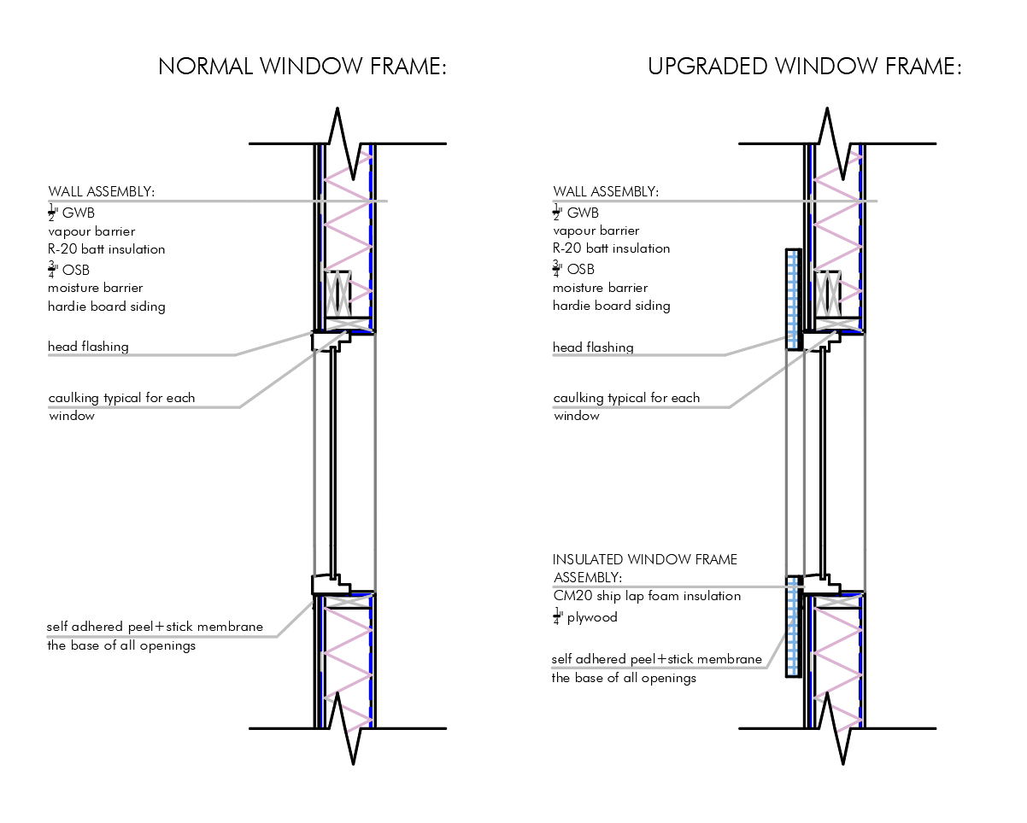

Figure 5: Taking Data 2

# Performance of Window Frame Panel

## Observations

When finding times to get recordings the most difficult part was getting direct sunlight for a consistent amount of time for an accurate number. There were a surprising number of factors that went into finding clean data collected in Figure (1). For example, if it had just rained the air would warm up faster than the vinyl and the vinyl faster than the upgraded panel which gave the panel a big advantage when it comes to staying cool. But when the days were mostly cloudy and temperature sat close to room temperature (20°C) the window frame panel was almost negligible. The window panel was most efficient when the weather was the warmest showing up to 9.4% more effective than the normal window frame as seen in Figure (2). When the window data was collected Figure (1) and analysed Figure (2) the upgraded window frame averaged five percent better than a standard base model Jeld-Wen window.

## Conclusion

Based on the observations made this summer it is clear you will see an improvement in your window frames. The cost to build a window with the window insert will be very minimal as the owner will already be using the same materials for other parts of project. This will be a great alternative to buying an upgraded window package with the new regulations for “step code [7]” setting in. I believe this is an effective and efficient way to upgrade a houses envelope.

**REFRENCES**

[1] Stapley, M., 2017. *How Much Do Canadian Households Spend On Energy? - Best Home Security & Automation*. [online] Best Home Security & Automation. Available at: <https://www.fluenthome.com/much-canadian-households-spend-energy/> [Accessed 28 November 2020].

[2] thehousedesigners.com. 2020. Top 5 Energy-Efficient Windows | The House Designers. [online] Available at: <https://www.thehousedesigners.com/top-product-picks/top-5-energy-efficient-windows.asp> [Accessed 28 November 2020].

[3] "Window Frame Types | Efficient Windows Collaborative", *Efficientwindows.org*, 2020. [Online]. Available: https://www.efficientwindows.org/ftypes_nonmetal.php. [Accessed: 12- Feb- 2020].

[4]Canadian Choice Windows. 2020. Double Pane Or Triple Pane Windows?. [online] Available at: <https://www.windowscanada.com/whitepages/double-pane-or-triple-pane-windows.html> [Accessed 28 November 2020].

[5]<https://climate.weather.gc.ca/climate_normals/station_select_1981_2010_e.html?searchType=stnProv&lstProvince=BC&txtCentralLatMin=0&txtCentralLatSec=0&txtCentralLongMin=0&txtCentralLongSec=0> [Accessed 28 November 2020].

[6] Timeanddate.com. 2020. *Sunrise And Sunset Times In Penticton*. [online] Available at: <https://www.timeanddate.com/sun/canada/penticton> [Accessed 28 November 2020].

[7] Energystepcode.ca. 2020. *Energy Step Code | Government Of British Columbia*. [online] Available at: <https://energystepcode.ca/> [Accessed 28 November 2020].